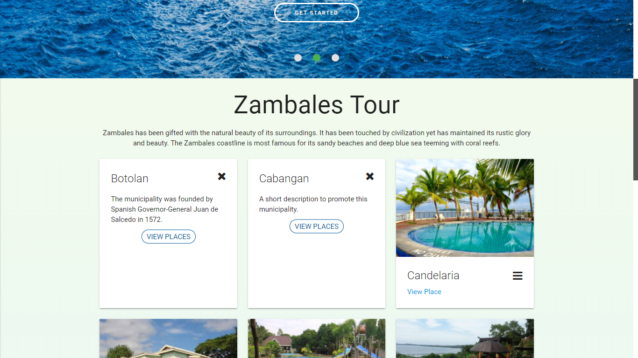

Saan napapalitan?

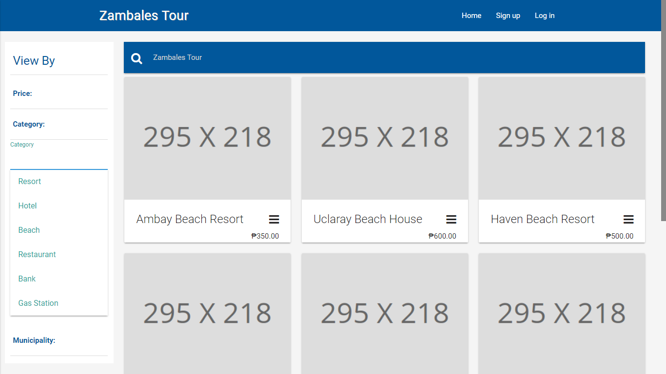

Category:

RESORT

HOTEL

BEACH

RESTAURANT

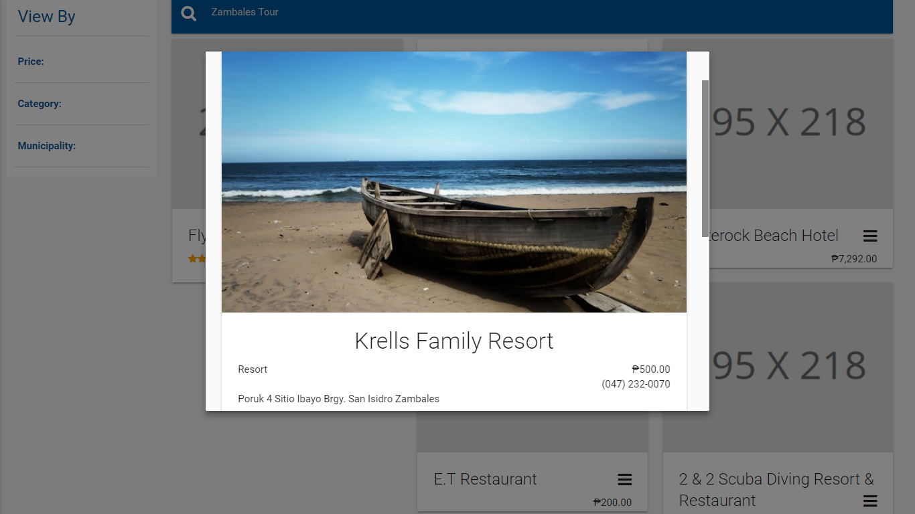

-Default picture only?

-gawing 5 pictures or carousel

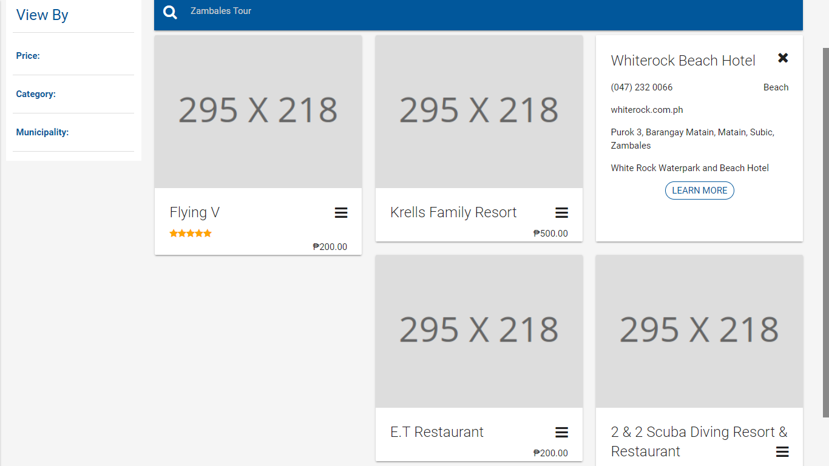

The website attach should be clickable

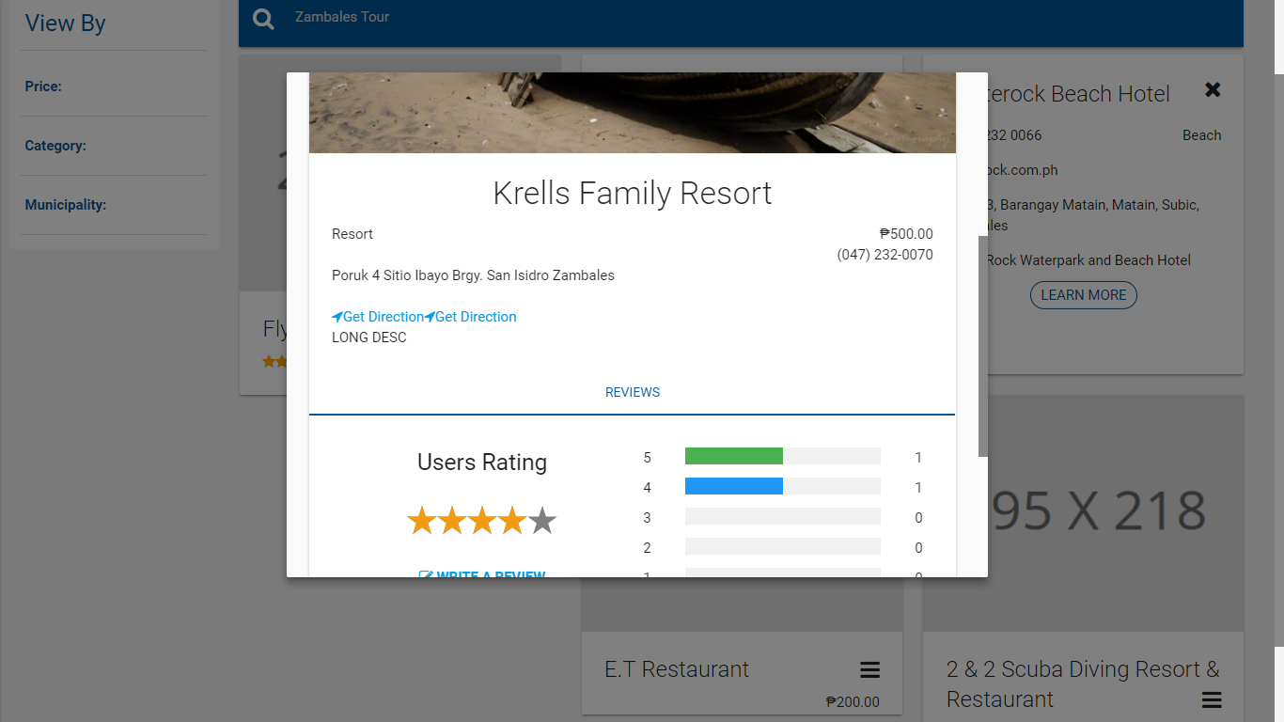

Bakit nagiging double?

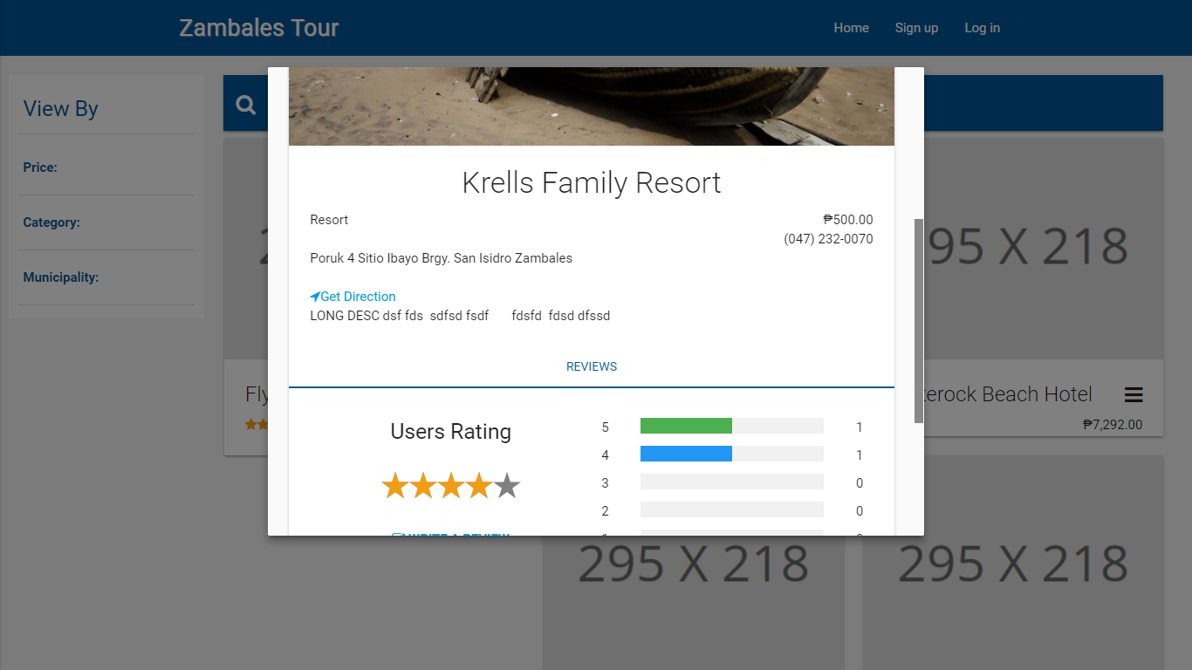

New line, new line for details

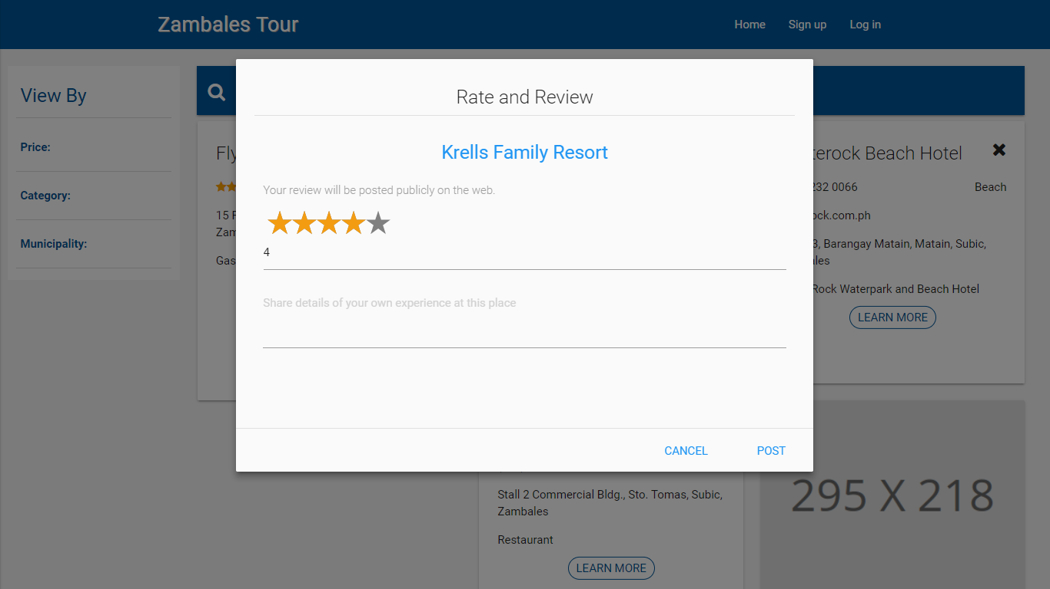

- When the tourist is not login there should be a pop-up message saying “Login or create account first”.

-before rating, post picture first for experienced showing that he/she is real that he visits the place

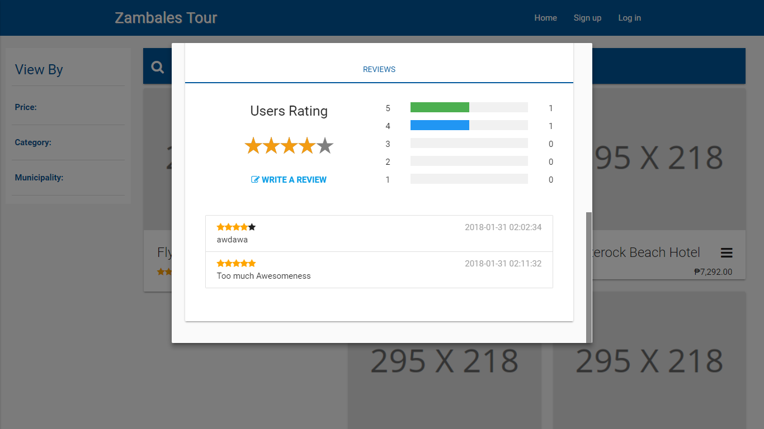

Name who rate?

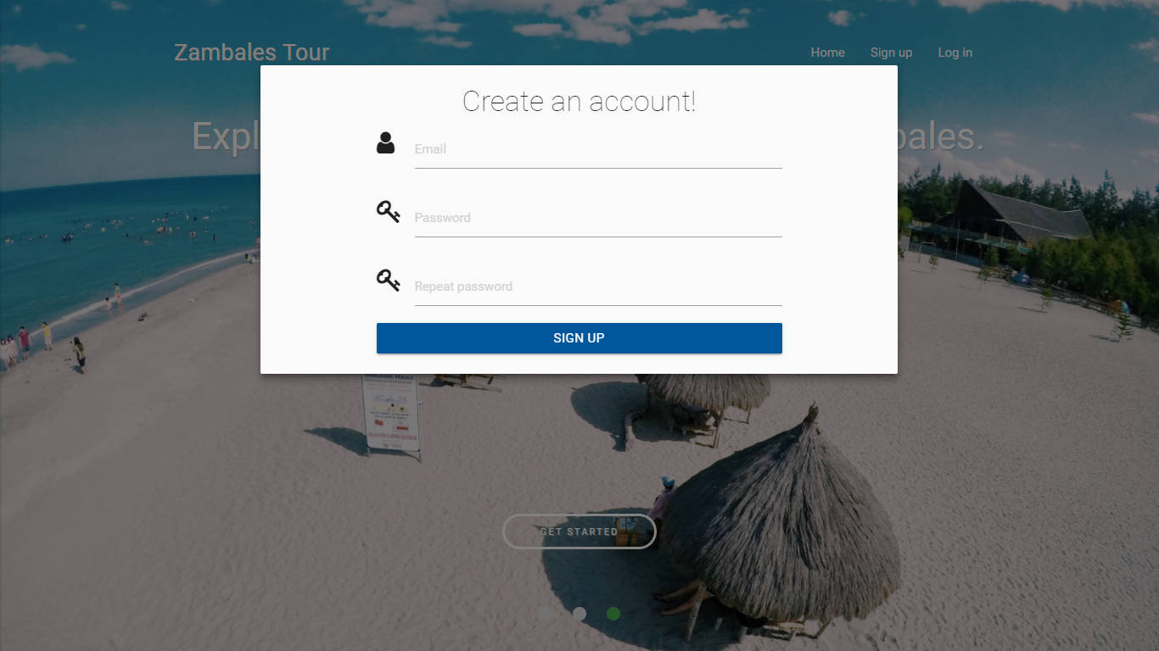

CREATE ACCOUNT:

BUTTONS:

-OWNER

-TOURIST

INFOS FOR OWNER AND TOURIST FOR SIGN UP:

-BUSINESS NAME (as the first name and email)

-CONTACT NO.

-PASSWORD

INFOS FOR OWNER AND TOURIST FOR SIGN UP:

-FIRST NAME

-LAST NAME

-EMAIL (GMAIL)

-PASSWORD

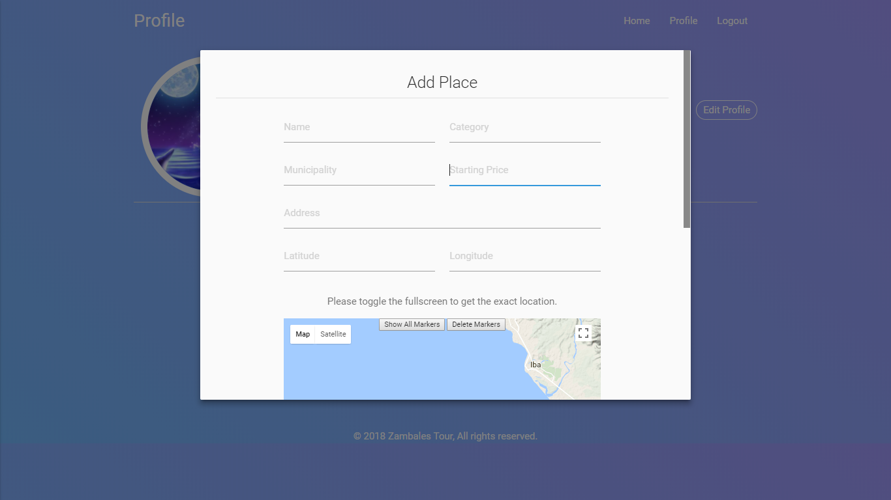

Indicate Peso Sign

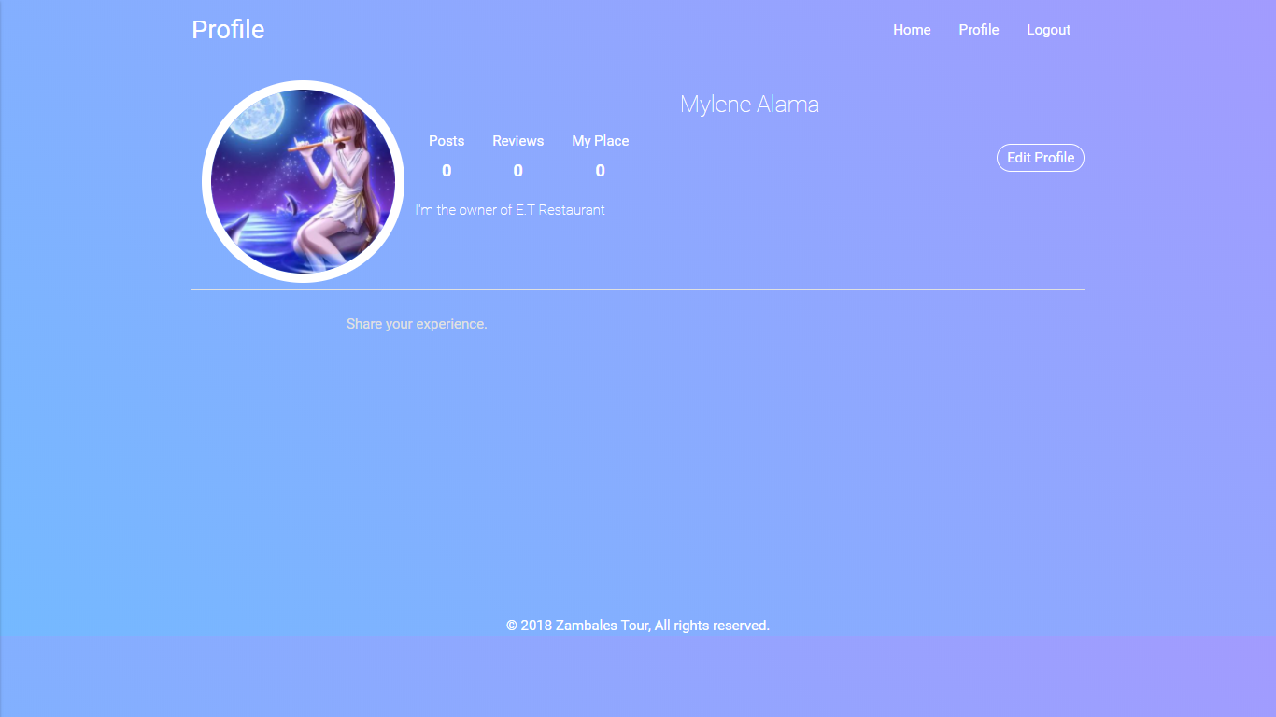

Add button for deactivation account

This is the owner account

The owner can’t review, post and shared experience. The owner should do add places only and can see the reviews of tourist.

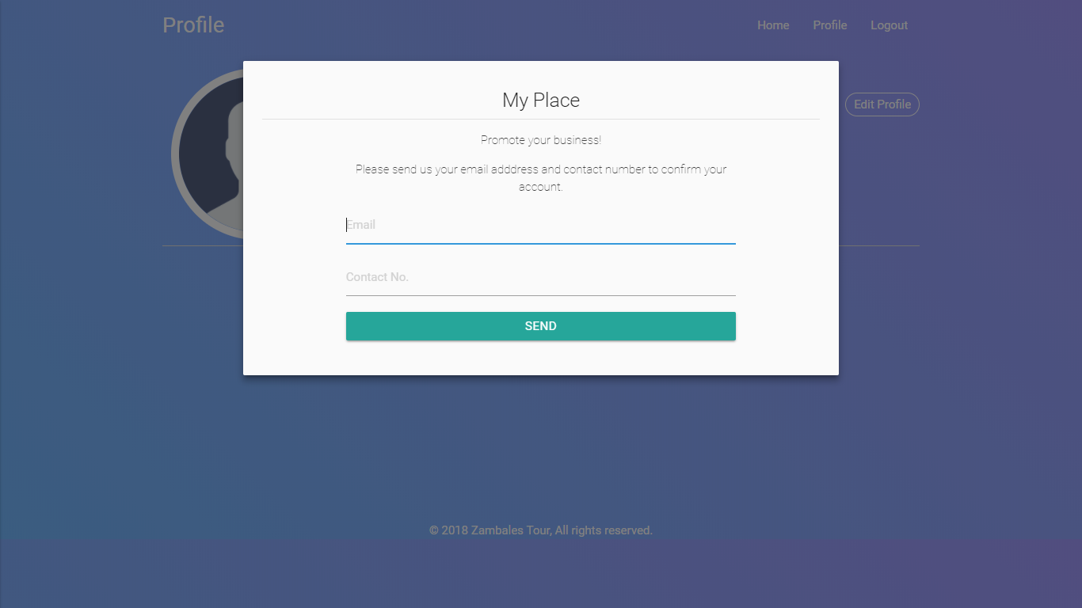

This is the owner account

Dapat sa sign up palang don na iaaccept ng admin kung siya talaga ang owner

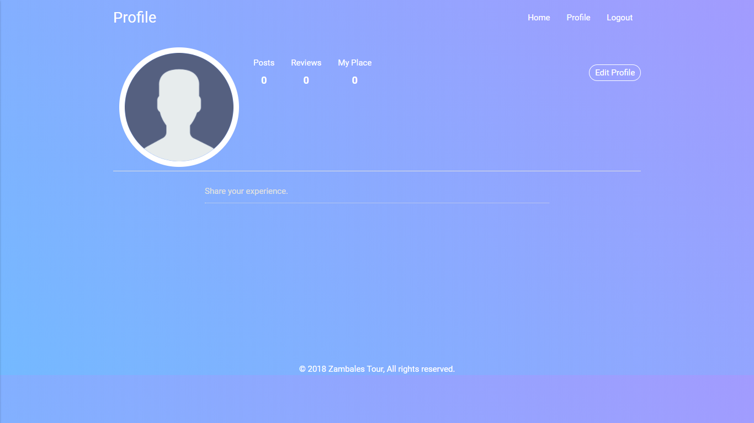

This is tourist account

Remove “my place”

This is tourist account

If possible dito i-show lahat ng pictures na i-share niya.

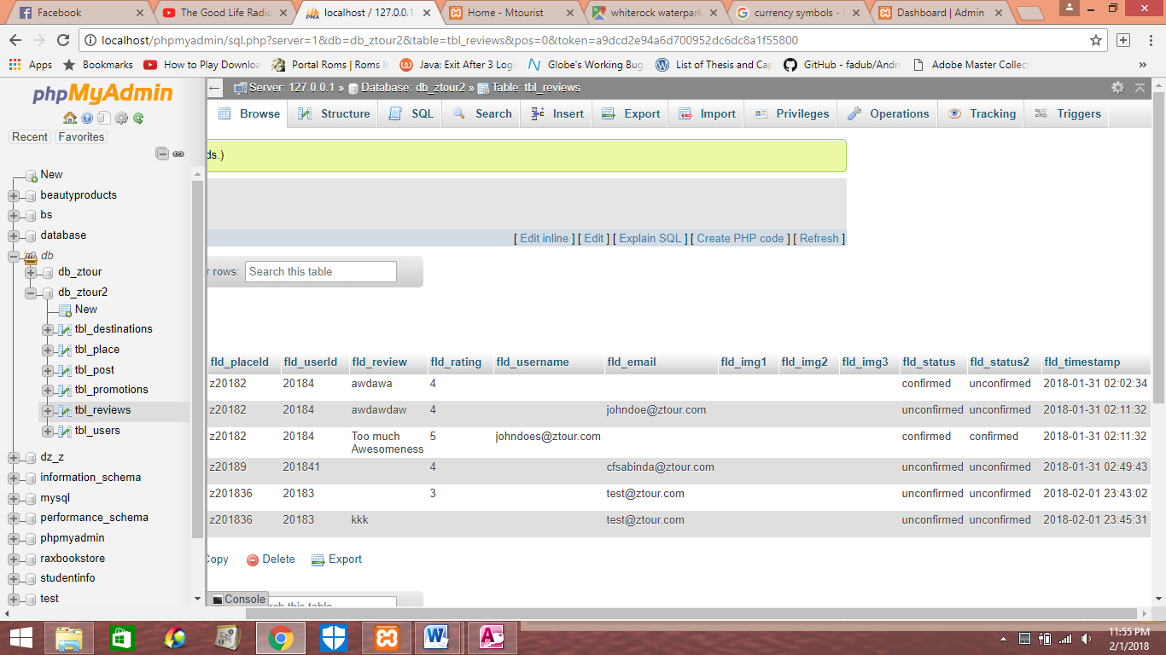

There is no confirm/unconfirmed in reviews

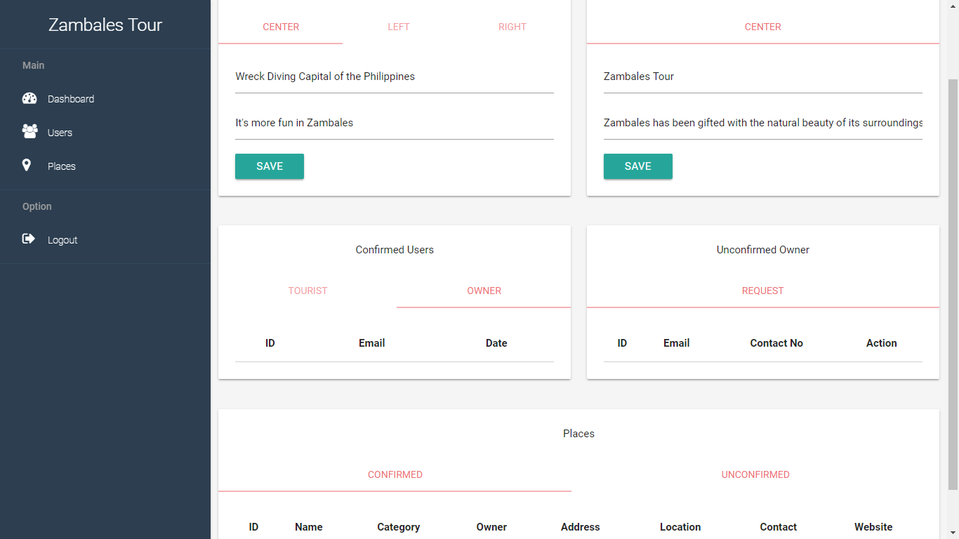

Include timestamp

Remove this